**Current position of ISS and the astronauts present on it: A Python Project**

**A PROJECT REPORT**

Submitted for the course: Open Source Development for Google Applications (EXC1081)

By

|  |  |
| --- | --- |
| **Chintan Rajvir** | **16BCE0017** |

Slot: TE2

**Name of faculty: Prof. Senthilnathan (GDG Faculty Advisor)**



APRIL 2018

Contents

Abstract 2

Introduction 2

Methodology 2

Results 5

Challenges faced: 5

Conclusion 6

References 6

Appendix 1 7

Appendix 2 8

# Abstract

The International Space Station (ISS) is a space station, or a habitable artificial satellite, in low Earth orbit. Its first component launched into orbit in 1998, the last pressurised module was fitted in 2011, and the station is expected to be used until 2028. We determine the current location of ISS and plot it on a map of Earth. We will also determine the astronauts present currently in the ISS and list the names alongside the map. For this we will be using APIs and python toolkits.

# Introduction

The International Space Station (ISS) is a multi-nation construction project that is the largest single structure humans ever put into space. Its main construction was completed between 1998 and 2011, although the station continually evolves to include new missions and experiments. It has been continuously occupied since Nov. 2, 2000.

As of January 2018, 230 individuals from 18 countries have visited the International Space Station. Top participating countries include the United States (145 people) and Russia (46 people). Astronaut time and research time on the space station is allocated to space agencies according to how much money or resources (such as modules or robotics) that they contribute. The ISS includes contributions from 15 nations. NASA (United States), Roscosmos (Russia) and the European Space Agency are the major partners of the space station who contribute most of the funding; the other partners are the Japanese Aerospace Exploration Agency and the Canadian Space Agency.

# Methodology

The libraries required to work on this project are: matplotlib, mpl_toolkits, and basemap from Python.

1. The first step to begin with is installation of Anaconda: a Python IDE for running programs using basemap and mpl_toolkits. The Anaconda can be downloaded from: <https://conda.io/docs/user-guide/install/download.html>. After successfully installing the software, move to next step.
2. Open the Anaconda Prompt to install libraries. Install the external libraries matplotlib, mpl_toolkits, and basemap. Note that the “requests” library will already be present.
3. After successfully installing each library, open the Anaconda Navigator followed by opening Spyder (Python 3.6 IDE).
4. Create a new file with extension “.py” in Spyder. Import the specified libraries.

from mpl_toolkits.basemap import Basemap

import matplotlib.pyplot as plt

import requests

1. We will be using 2 APIs to get the data: one for obtaining the ISS current location and the second for getting the names of astronauts present in the ISS currently.
   1. ISS Current Location: <http://api.open-notify.org/iss-now.json>
   2. Astronauts on ISS: <http://api.open-notify.org/astros.json>

url_People = 'http://api.open-notify.org/astros/'

peopleData = dict(requests.get(url_People).json())

url_ISS_Position = 'http://api.open-notify.org/iss-now/'

ISSData = dict(requests.get(url_ISS_Position).json())

The URL is API that will be used to obtain data. The “requests” library allows to import the data from the API and Python’s “dict()” command is used to convert JSON format data into a Python Dictionary.

1. The data obtained is used for making a string of names of all astronauts present in ISS.

s = ""

NoOfAst = peopleData['number']

listOfAst = peopleData['people']

for i in range(NoOfAst):

item = listOfAst[i]

s += item['name']

s += "\n"

1. Following this we store the latitude and longitude of the current location of ISS and then converting it into a Basemap point: (x, y). The projection can be of any choice referring: <https://matplotlib.org/basemap/users/mapsetup.html>.

LatLong = ISSData['iss_position']

latitude = float(LatLong['latitude'])

longitude = float(LatLong['longitude'])

m = Basemap(projection='cyl', lon_0 = 0)

x, y = m(longitude, latitude)

1. In this step we draw the map boundary, fill the continents, lake, and oceans with colours. Next we plot the point and add a title to the map.

m.drawmapboundary(fill_color='#3CF5F3')

m.fillcontinents(color='#C85353', lake_color='#3CF5F3')

m.plot(x, y, marker='o', color='black')

plt.title('Current ISS Location', fontsize = 12)

1. The next task is to add a text box on the map having the list of astronauts currently present at the ISS. The “bbox” creates a box and “arrowprops” creates and arrow from text to the point on the map.
2. The final command allows use to see the plotted map.

ax = plt.subplot(111)

ann = ax.annotate("ASTRONAUTS CURRENTLY \nAT ISS: \n"+s,

xy=(x, y), xycoords='data',

xytext=(-218, 0), textcoords='data',

size=10, va="center", ha="center",

bbox=dict(boxstyle="round4", fc="w"),

transform=plt.gcf().transFigure,

arrowprops=dict(arrowstyle="simple", connectionstyle="arc3,rad=-0.2",fc="w"),)

plt.show()

The complete code can be fetched from Appendix 1.

# Results

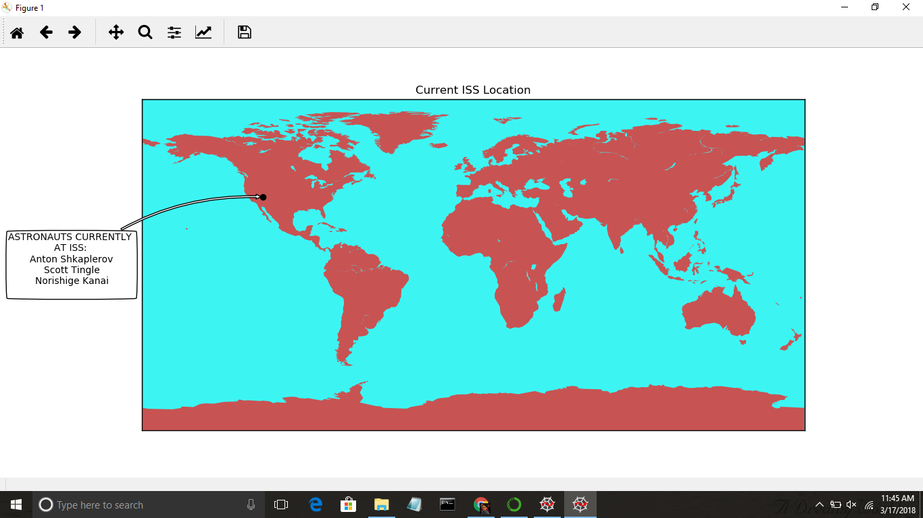For various other positions of ISS go to Appendix 2.

## Challenges faced:

* The first challenge was discovering that Basemap library is an external Python library not compatible with Python3 IDE on Windows. This allowed to explore the Anaconda IDE which is most suitable for Python GUI and API programming.
* The second challenge was to place a textbox out of the map which contains the list of astronauts currently present at the ISS. Initially I just knew about placing it using the co-ordinates of map itself. But later on, I could shift it outside the map using the “transform characteristic” in the “annotate” function call.

# Conclusion

I learnt the API programming in Python for the first time along with knowing few external libraries of Python which cannot be installed using “pip”. The project allowed me to know more about ISS. Like recently I learnt that a robot named CIMON (short for Crew Interactive Mobile Companion) will be a future member of the ISS. It is equipped with AI technology and will assist astronauts during the European Space Agency’s Horizons Mission. The robot will not be alone; INT-BALL is a 3D-Printed Drone that was created by the Japan Aerospace Exploration Agency will also be there. Therefore, the project was a great aid in knowledge improvement in various aspects as mentioned.

# References

1. <http://api.open-notify.org/astros.json>
2. <http://api.open-notify.org/iss-now.json>
3. <https://www.anaconda.com/download/>
4. <https://conda.io/docs/commands/conda-install.html>
5. <https://www.nasa.gov/mission_pages/station/main/index.html>
6. <https://en.wikipedia.org/wiki/International_Space_Station>
7. <http://iss.astroviewer.net/>
8. <https://matplotlib.org/basemap/users/mapsetup.html>
9. <http://basemaptutorial.readthedocs.io/en/latest/projections.html#projection>
10. <http://basemaptutorial.readthedocs.io/en/latest/plotting_data.html>
11. <https://stackoverflow.com/questions/42435446/how-to-put-text-outside-python-plots>
12. <https://htmlcolorcodes.com/>
13. <https://matplotlib.org/users/annotations.html#annotating-with-text-with-box>
14. <https://anaconda.org/conda-forge/basemap>
15. <https://sourceforge.net/#!/projects/matplotlib/postdownload>
16. <https://stackoverflow.com/questions/36240495/bound-method-response-json-of-response-200/36240505>

# Appendix 1

from mpl_toolkits.basemap import Basemap

import matplotlib.pyplot as plt

import requests

url_People = 'http://api.open-notify.org/astros/'

peopleData = dict(requests.get(url_People).json())

url_ISS_Position = 'http://api.open-notify.org/iss-now/'

ISSData = dict(requests.get(url_ISS_Position).json())

s = ""

NoOfAst = peopleData['number']

listOfAst = peopleData['people']

for i in range(NoOfAst):

item = listOfAst[i]

s += item['name']

s += "\n"

LatLong = ISSData['iss_position']

latitude = float(LatLong['latitude'])

longitude = float(LatLong['longitude'])

m = Basemap(projection='cyl', lon_0 = 0)

x, y = m(longitude,latitude)

m.drawmapboundary(fill_color='#3CF5F3')

m.fillcontinents(color='#C85353', lake_color='#3CF5F3')

m.plot(x, y, marker='o', color='black')

plt.title('Current ISS Location', fontsize = 12)

ax = plt.subplot(111)

ann = ax.annotate("ASTRONAUTS CURRENTLY \nAT ISS: \n"+s,

xy=(x, y), xycoords='data',

xytext=(-218, 0), textcoords='data',

size=10, va="center", ha="center",

bbox=dict(boxstyle="round4", fc="w"),

transform=plt.gcf().transFigure,

arrowprops=dict(arrowstyle="simple", connectionstyle="arc3,rad=-0.2",fc="w"),)

plt.show()

# Appendix 2